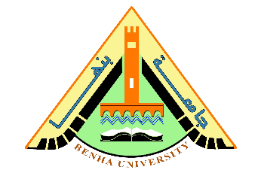
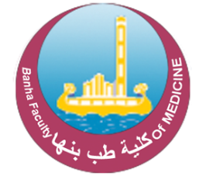
C.V
Prof. Dr. Osama Fouad Ahmed Ibrahim
Benha University
1. Personal Data:

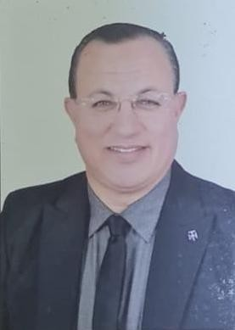
- Name: Osama Fouad Ahmed Ibrahim
- Faculty: Faculty of Medicine – Benha University
- Position: Professor, Department of Radiological Anatomy and Embryology
- Date of Birth: 14/03/1970
- Place of Birth: Qalyubia Governorate
- Marital Status: Married, with dependents
- Email:
Osamafouad20@yahoo.com
osamafouad733@gmail.com
Osama.ibrahim@fmed.bu.edu.eg
- Website:
www.Alfouadscan.com
2. Career Progression:
Place | Date | Position
Directorate of Health Affairs | 01/03/1995 | General Practitioner (Mandatory Service) at Benha Child Care Center
Directorate of Health Affairs | 27/10/1998 | General Practitioner at Kafr Shukr Central Hospital
Benha Health Insurance Hospital | 1996–1998 | Emergency Physician, Diagnostic Radiology Resident
Benha University – Faculty of Medicine | 1998 | Demonstrator
Faculty of Medicine – Benha University | 28/10/2003 | Assistant Lecturer
Faculty of Medicine – Benha University | 26/04/2009 | Lecturer
Faculty of Medicine – Benha University | 2018 | Assistant Professor
Faculty of Medicine – Benha University | 2023 | Professor

Place | Year | Degree
Faculty of Medicine – Benha University | 1995 | Bachelor of Medicine and Surgery (M.B.B.Ch.)
Faculty of Medicine – Benha University | 19/02/2000 | Master’s Degree in Diagnostic and Interventional Radiology
Faculty of Medicine – Benha University | 2001 | Master’s Degree in Anatomy and Embryology
Faculty of Medicine – Benha University | 24/03/2009 | Doctorate (PhD) in Study of the Sphenoid Sinus Using Computed Tomography
Ministry of Health | 23/01/2007 | Specialist Registration in Diagnostic Radiology (No. 1351)
Qalyubia Medical Syndicate | 05/11/2014 | Third-Level Consultant in Diagnostic Radiology (No. 1083)
Qalyubia Medical Syndicate | 05/11/2014 | First-Level Consultant in Diagnostic Radiology
3. Educational Qualifications:

4. Academic Activities:
Academic Advising: Academic Advisor
Administrative & Quality Roles
- Green University Initiative: Head of the Green University Unit, Faculty of Medicine, Benha University
- Quality Assurance: Director of the Radiological Anatomy Unit, Faculty of Medicine, Benha University

Courses Taught
(A) Undergraduate Level
- Fundamentals of Anatomy
- Fundamentals of Embryology
- Fundamentals of Radiological Anatomy
- Anatomy of the Upper and Lower Limbs
- Anatomy of the Thorax, Abdomen, and Pelvis
- Specialized Embryology
- Anatomy of the Head and Neck
- Neuroanatomy (Brain and Nerves)
(B) Postgraduate Level
- Teaching postgraduate curriculum for the Department of Rheumatology and Orthopedics (Master’s Program)
- Teaching postgraduate curriculum for the Departments of Rheumatology and Internal Medicine (Doctoral Program)
- Participation in preparing Master’s and Doctoral examinations
- Supervision and follow-up of examination processes and result tabulation as Head of Department for Master’s and Doctoral programs
5. Scientific and Research Activities:
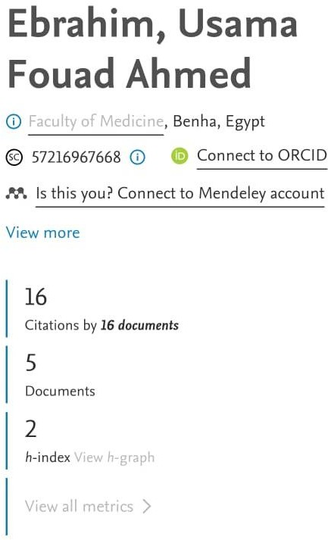
International Research Indicators:

https://www.scopus.com/authid/detail.uri?authorId=57216967668

6. Conferences, Symposia, and Workshops:
No. | Role | Date | Event
1 | Attendee | 15/11/2001 | 25th Annual Conference of Anatomy and Embryology, Al-Azhar University
2 | Attendee | 17/11/2005 | 29th Annual Conference of Anatomy and Embryology, Ain Shams University
3 | Lecturer | 2009 | X-RAY COURSE (One 4 ALL Family)
4 | Attendee | 2014 | Annual Scientific Conference: Erectile Dysfunction Update
5 | Attendee | 15/11/2007 | 31st Annual Scientific Conference, Department of Anatomy, Al-Azhar University
6 | Attendee | 23/11/2000 | 24th Annual Conference of Anatomy and Embryology, Ain Shams University
7 | Attendee | 11/12/2003 | 26th Annual Conference of Anatomy and Embryology, Ain Shams University
8 | Attendee | 21/05/2005 | 27th Annual Conference of Anatomy and Embryology, Cairo University

7. Statement of Dr. Osama Fouad Ahmed Ibrahim’s Scientific Activities, Conferences, Workshops, and Theses

1. University Teaching and Educational Activities
- Teaching Anatomy to first- and second-year medical students (lectures and practical sessions).
- Participation in teaching Anatomy courses within the new integrated curriculum.
- Practical teaching for postgraduate students in various specialties, in addition to Anatomy specialization.
- Participation in periodic examinations (theoretical, practical, and oral) for first- and second-year students.
- Contribution to the preparation and publication of practical manuals for first- and second-year students.
- Teaching for Dentistry and Pharmacy students at Misr International University : 2003 (MIU)

2. Departmental and Faculty Activities
- Participation in exam control and administration.
- Contribution to quality assurance activities within the department.
- Participation in faculty-level quality assurance initiatives.

3. Scientific Activities within the Department
- Participation in regular scientific seminars and departmental study circles.

4. Participation in Conferences, Workshops, and Awards
- Attended the Scientific Conference in Dubai, April 2019 (Arab Health).
- Received a Certificate of Appreciation from the University President for scientific research and international publications (7th Scientific Excellence Day, January 2021 cycle).
- Attended the training workshop titled “Environmental Analysis of the New Strategic Plan and Follow-up System” at the Central Unit for Strategic Planning on Monday, 29/11/2021.

5. Faculty Development Courses at the University
- Attended the Strategic Planning training course, part of the Faculty and Leadership Development Program – Benha University, from 21/11/2022 to 22/11/2022.
- Attended and completed the Statistical Analysis training course, part of the Faculty and Leadership Development Program – Benha University, from 23/11/2022 to 24/11/2022.
- Attended the Self-Assessment and External Review training course, part of the Faculty and Leadership Development Program – Benha University, from 27/11/2022 to 28/11/2022.
- Attended the Website Management training course, part of the Faculty and Leadership Development Program – Benha University, from 29/11/2022 to 30/11/2022.
- Attended the Question Banks and E-Exams training course, part of the Faculty and Leadership Development Program – Benha University, from 05/12/2022 to 06/12/2022.
- Attended the Digital Transformation training course, part of the Faculty and Leadership Development Program – Benha University, from 27 to 31 May 2021.

8. Certificates and Awards:
- Certificate of Excellence in International Publication and Scientific Research, 2022
- Certificate of Practice in International Commercial Arbitration, December 2022
- Registration and Practice Certificate from the Union of Arab International Arbitrators (International Arab Authority), December 2022
- Certificate of Attendance: Training Program in Diplomatic and Consular Relations, December 2022
- Certificate of Participation: Training Program in Diplomatic and Consular Relations, December 2022
- Certificate of Appreciation for Continuous Efforts with Students and Collaboration with the ALL 4 ONE Team, 13/03/2008
- Bachelor of Medicine and Surgery (M.B.B.Ch.), Zagazig University – Benha Branch, Certificate No. 119949, December 1993
- First-Level Consultant Certificate (Diagnostic Radiology), No. 1083, 05/11/2014
- Master’s Degree in Diagnostic Radiology
- Master’s Degree in Radiological Anatomy and Embryology
- Doctorate (PhD) in Computed Tomography of the Sphenoid Sinus
- The Egyptian International Arbitration Center (EIAC) – Offers the Highest State of Appreciation, December 2022
- Center of Arbitration, Faculty of Law, Ain Shams University – Certified Attendance from 15/12/2022 to 17/12/2022
Member, Egyptian Society of Diagnostic Radiology
9. Scientific Societies, Committee, and Council Memberships:
- Member, Egyptian Society of Anatomy and Embryology
- Member, International Society of Radiology (ISR) – Diagnostic and Interventional Radiology
Departmental and Faculty Committees:
- Member, Department Council of Anatomy and Embryology (2009–2023)
- Member, Library Committee (2017–2019)
- Member, Faculty Council (2023–Present)
- Member, Laboratory and Practical Work Committee (2019–2021)
- Member, Postgraduate Studies Committee (2022)
- Member, Community and Environmental Development Committee (2023–2024)
- Head, Sustainable Development Unit, Faculty of Medicine, Benha University (2023–2024)
- Member, Green University Committee (2023–2024)
- Director, Continuous Medical Education Center (2024)

10. Activities in the Field of Higher Education Quality Development and Accreditation:

Administrative and Honorary Positions
- 2015 – National Authority for Quality Assurance and Accreditation of Education (NAQAAE): Coordinator of the Field Visit for the Accreditation of Benha University Faculty of Medicine.
- 2016 – Faculty of Medicine, Benha University: Member of the Quality Assurance Unit.
- Member of the Executive Team for the Establishment of the Internal Quality System (QAAP2).
- 2023 – Head of the Department of Anatomy and Embryology, Faculty of Medicine, Benha University.
- 2024 – Director of the Sustainable Development and Green University Unit, Faculty of Medicine, Benha University.
- 2024 – Director, Continuous Medical Education Center.

Consulting Work in the Field of Higher Education Quality
- Faculty of Medicine, Benha University: Participant in the Quality Assurance and Accreditation Unit.

11. Training Courses:
Venue | Period | Course Name
Benha University | 14/07/2021 | Fundamentals of Digital Transformation at the Training Lab, Faculty of Accounts
Benha University | 15–17/12/2022 | Specialized Course in Arbitration in Consular and Diplomatic Disputes
Benha University | 16/12/1996 | Participated in the First Annual Conference in Laparoscopic Surgery
Benha University | 11–19/09/2000 | Training Course in DOS
Benha University | 28–30/08/2005 | Ethics and Professional Conduct (P4)
Benha University | 12–15/06/2006 | Scientific Research Methods (T7)
Benha University | 17/06/2006 | Basic Concepts of Information Technology
Benha University | 24/06/2006 | Operating System (Windows)
Benha University | 31/03–12/04/2007 | University Teacher Preparation Program (No. 50)
Benha University | 19–20/11/2005 | Medical Statistics in Clinical Use
Benha University | 02–05/07/2006 | Training Program on Word Processing (MS Word)
Benha University | 10/07–13/06/2007 | Effective Teaching (T1)
Ain Shams University | 01/08/2001 | TOEFL Test – Completed
Benha University | 01/10/2010 | Competency in Operating Mobile, Digital, and Color Doppler Radiology Equipment for ICU
Benha University | 10–12/11/2015 | International Scientific Publishing

12. Higher Education Development Projects:
- Internal Quality System Project (QAAP2) at the Faculty of Medicine, Benha University (2016–2018)
- Member of the Quality Assurance Units at Benha University
13. Computer Skills:

- Microsoft Word (MS Word)
- Microsoft PowerPoint (MS PowerPoint)
- Microsoft Access (MS Access)
- Microsoft Excel (MS Excel)
- Internet
- ICDL Certificate
- Other software programs

